Mitchener University Academy 2026-27 School Calendar
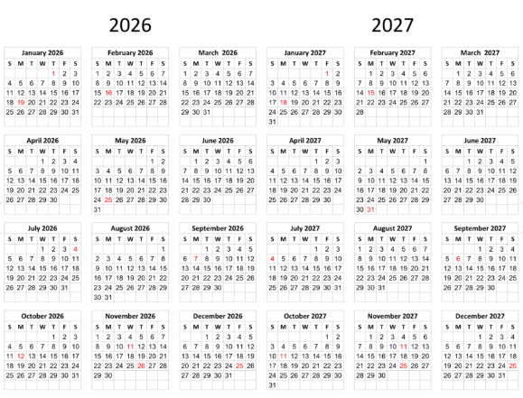
Calendar Days & Dates
July 1st First Day of School Last Day of School June 4th, 2026
September 1st Labor Day November 11th Veteran’s Day
January 1st New Year’s Day January 4th School Resumes
January 18th MLK May 31st Memorial Day
Graduation June 4th

Grading Periods
Quarter One: July 1st – Oct 4th
Quarter Two: Oct 5th – Dec 31st
Quarter Three: Jan 4th – Mar 14th (2027)
Quarter Four: Mar 15th – May 31st (2027)
Built in Breaks
Fall Break
Monday, October 5 – Friday, October 9, 2026
Thanksgiving Break
Thursday, November 26 – Friday, November 27, 2026
Winter Break
Monday, December 21, 2026 – Friday, January 1, 2027
Spring Break
Monday, April 5 – Friday, April 9, 2027

Report Cards
Quarter One: Oct 5th
Quarter Two: Dec 14th
Quarter Three: Mar 15th (2027)
Quarter Four: May 24st (2027)

